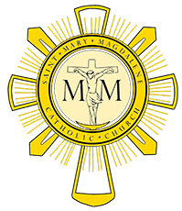
Pastoral Council Meeting September 14, 2017

Members Present: Mike Rimbey, Kathy Dyer, Gary Livacari, Mike McCartney, Deb Able, Eric Scheer and Fr Will Schmid.
- Opening prayer @ 7:05

- August meeting minutes were read and approved.

- Father Will’s update:
  - Father Ken has left the Parish to minister at Camp Pendleton
  - Father Steve Peterson is a retired priest who will assisting with Mass and confessions
  - Ryan Stenborg, the evening facilities person, will be leaving the parish and the current cleaning company has a service that we can contract with to cover his duties and lesser cost
- Strategic Plan updates
  - Kathy D. – Enhanced Ministries
    - Father Ken has left but Deacon John will sponsor
    - Strategies have been defined
    - Currently brainstorming ideas to accomplish strategies
    - Prioritizing ideas from brainstorm sessions
    - Estimating costs of activities
    - Creating communication plan
  - Deb A. – Respect Life
    - Has found that her current workload has slowed her progress but is getting her arms around managing it.
    - Looking to coordinate with Diocese
    - Already has sponsorships for Holy Hours
  - Gary L. – Integrating new families into Parish
    - Work currently on identifying mentors for new families to create an organic authentic Catholic Faith Life.
  - Mike M. – Integration of Faith into Lifestyle
- Still conducting brainstorming
- Have created a chatroom to exchange ideas with committee members in an attempt to increase ideas and productivity without taxing member’s family life.

- Meeting was adjourned at 8:07PM

