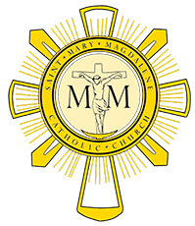
Pastoral Council Meeting
October 20th, 2016
Members Present: Mike Rimbey, Debra Abel, Kathy Dyer, Gary Livacari, Mike McCartney, Laura Oeinck, Domonic Salce, and Fr Will Schmid.

- Opening prayer @ 7:02

- Motion and second was made to approve the minutes from the September 29th meeting. Minutes approved with 1 addition.

- Fr. Will went into more depth of the pros and cons of the two possible options for fund raising and made sure the council had no additional questions or comments. He had already received approval from the council and staff to go with option 2. This option allows St. Mary Magdalene to fund raise separately from the future diocesan campaign for education.

- Fr. Will and Fr. Ken are planning small group information sessions for anyone wanting more information about the building plan and what the thought process is behind it.

- Fr. Will was asked for an update on the new rectory. He is hoping construction can start the beginning of 2017.

- Fr. Will has been approached about having an early morning mass. He would like to conduct a survey to find out what time would serve the most people.

- November 3rd meeting has been canceled.

- December 1st meeting will be the Pastoral Christmas Party @ Eric and Beth Sheer’s home if that date is amenable to them.

- Closing prayer @ 8:15

