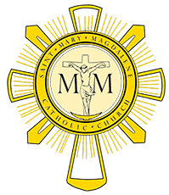
Pastoral Council Meeting January 11, 2018

Members Present: Scott Fleckenstein, Laura Oeinck, Gary Livacari, Deb Abel, Eric Scheer and Fr Will Schmid.
- Opening prayer @ 7:04

- November’s meeting minutes were read and approved with two corrections

- Father Will’s update:
  - Christmas was went very smoothly and was well attended. It is estimated that 6,000 attended all the Masses.
- Strategic Plan updates
  - Deb A. – Respect Life
    - No new updates
  - Gary L. – Integrating new families into Parish
    - Close to implementing the initiative
      - Launching with s social event end of April or early May
      - Nearly ready to begin welcoming new families with “welcome basket” that may contain items such as info on the parish, a rosary, holy water and similar items.
        - Gary plans on bringing a sample of the package to next meeting
  - Laura O. – Singles Ministry
    - Advertised in bulletin and will make pulpit announcement soon. So far no interest.
  - Scott F. – Fallen away Catholics
    - Narrowing down the list of committee members.
- Meeting was adjourned at 7:40 pm

