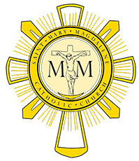
Pastoral Council Meeting October 19, 2017

Members Present: Scott Fleckenstein, Laura Oeinck, Gary Livacari, Mike McCartney, Dominic Salce, Deb Abel, Eric Scheer, Mike McCartney and Fr Will Schmid.
- Opening prayer @ 7:05

- September’s meeting minutes were read and approved.

- Father Will’s update:
  - Father Ishaya will be on vacation till November 3
  - Christmas is on a Monday, therefore there will be 12 Masses in 48 hours.
- Strategic Plan updates
  - Deb A. – Respect Life
    - Has initial draft of plan
    - Goal is to get Respect Life initiative set into the DNA of our Parish
    - Will interview at least six parish pro-life leaders and three to be organization leaders
    - A suggestion was raised to include adoptions.
  - Gary L. – Integrating new families into Parish
    - Has been reaching out to community for input
    - A challenge is how to draw new families into community of Christ
    - Looking to attract mentor families.
  - Mike M. – Integration of Faith into Lifestyle
      - Plan is in neutral for a short time while they set strategy
  - Laura O. – Singles Ministry
    - One new committee members
    - Met with Lita to discuss plans
  - Scott F. – Fallen away Catholics
    - Working with the office and Lita to id potential fallen away Catholics
- Meeting was adjourned at 8:20PM

